STL Robot project

We want to have a robot that can fill out a form as human as possible, it must be trigger when a new row is added to our SQL database

We need the robot to have:

* Different times of submission
  + The overall time of the submission must be different <X>
  + Before start filling out the form there must be a waiting time between 20 and 120 seconds <X>
* Different speeds of typing letter by letter (can’t be copy and paste the whole text)
  + It needs to show as if somebody was typing letter by letter the information we have in the database, and if the information is not found, it must make it up. Speed must be between 20 and 120 milliseconds. <X>
  + Values should not be enter/type from Query strings, sessions, or any view states in landing page. <X>
* Different types of scroll up and down
  + While the robot is waiting to fill out a page or the next field, it should scroll up and down, simulation as the person in reading the different things in the page. <X>
* Mouse should move around the page randomly.
  + As a human, we move the mouse around the page to read or to have a guide, so it is important that the mouse moves around as it scrolls in the waiting periods. <X>
* It must use a different IP address every time depending on the zip code of the information
  + The robot must have the ability to show a different IP based on the zip, if the person is from a specific zip code from FL, then it has a show an IP as close to that zip code or county as possible. <X>
* It must show different mobile phones and different systems (iOS, Android, windows, others)
  + The robot must show that he is accessing the page from different devices, iPhones, Samsung, Desktop, Windows, and others, as well as different operation systems based on the device <X>
* Different browsers (Chrome, Firefox, Safari, others) <X>
* The Robot has to have an API where we can send the information it needs to fill out and trigger it as well.
  + Developer will have to provide API documentation to connect to it.
* The robot must be able to submit at leads 5 leads or more at the time, if the robot gets more than that, then it must put them in queue, while the other ones get done. <X>
  + The robot cannot miss any lead sent to it. <X>
* There must be a portal where we can see the report of the robot, in daily and hourly bases, showing there were any errors, successfully leads submitted <X>
  + We must be able to download the information in a CSV file with full details leads by leads <X>
* We will provide access to a Linux server where you will set up anything we need to get the robot going.

Page the Robot is going to fill out:

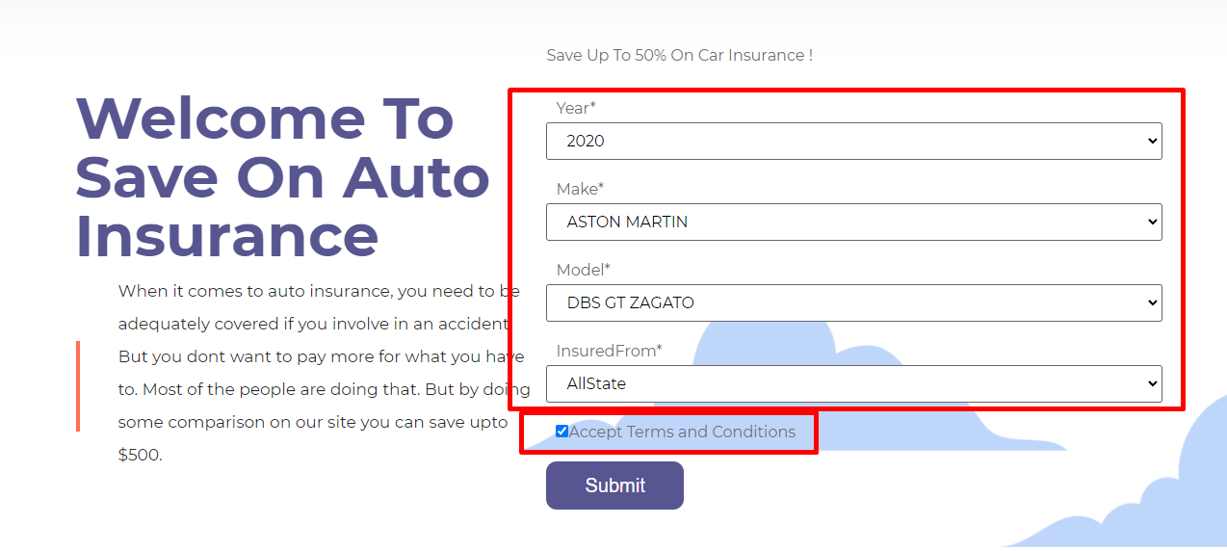

* First page must select Year (> 2012), Make, model and insured from, randomly <X>
* Accept term and conditions check box must be clocked every time <X>



At the bottom of the page there is a Terms of use and Privacy policy links, we should have a couple of leads a day to go to those pages an read some of that, same thing, move mouse, scroll up and down for a few minutes, 30 to 120 seconds.<X>

Second page

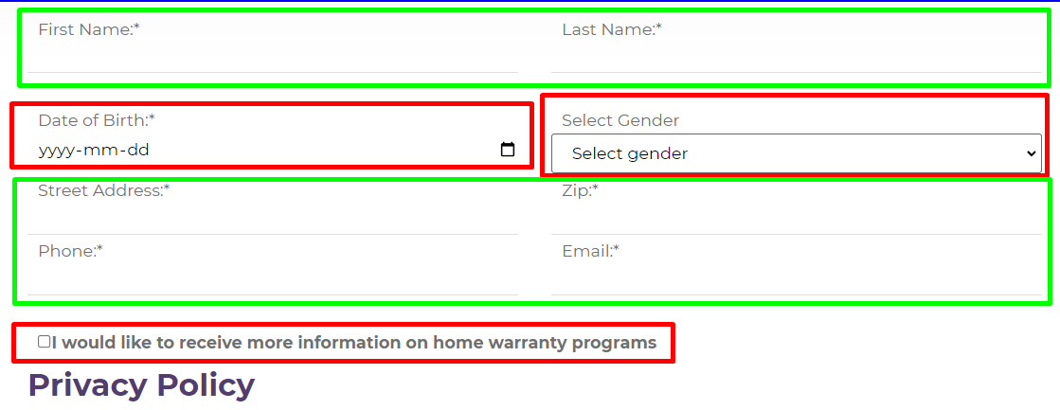

* Thru the API you will receive the information in green. <X>
* Date of birth must be generated by the robot if didn’t receive thru the API (between 61 and 23 years old) <X>
* Gender must be set based on the first name of the person. <X>
* Check box must be checked every time “I would like to receive more information on home warranty program <X>

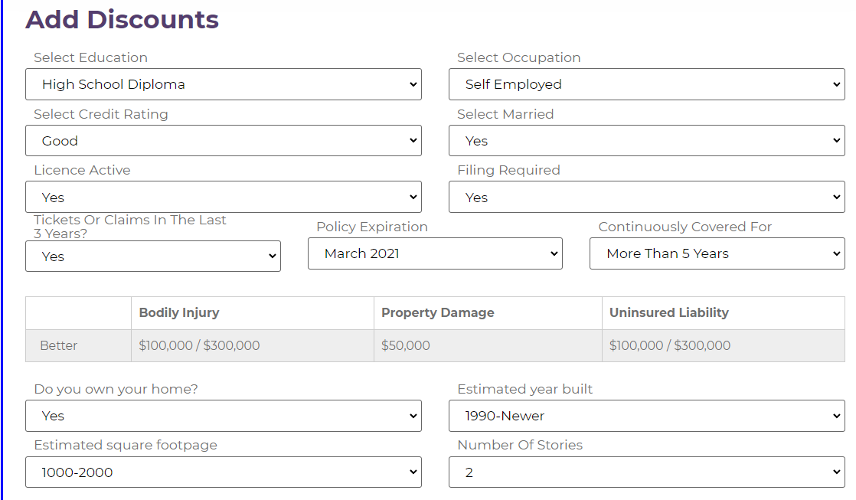

Education: random <X>

Educations: Default <X>

Credit Rating: Good or excellent <X>

Married: No <X>

License Active: Default <X>

Filing Required: Default <X>  
Ticket in the last 3 years: No <X>

Policy Expiration: Randon date between 2 and 5 months ahead. <X>

Continuously covered for: Default <X>

Do you own your Home? Default <X>

Estimate year built: Default <X>

Estimate square footpage: Default <X>  
Number of stories: Default <X>

3rd page

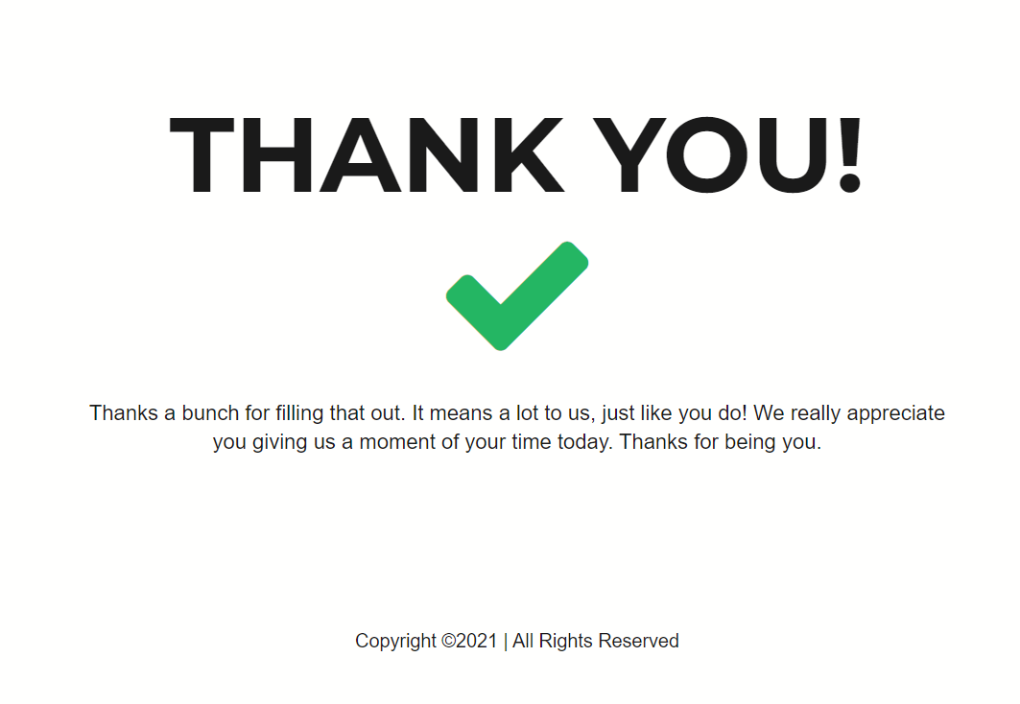

* Stay in the thank you page a random time between 10 and 30 seconds <X>

The whole idea es that it can show as human as possible.

Requirements.

Send us all the question you may have about the project

Send examples of a similar projects you did before where we can see your experience in the type of automations.

Answer the following questions:

* What type of language and technology are you going to use for this project?
  + Python
* Where are we going to allocate this project?
  + Company will provide Server
* How are going planning to fix the IP portion of the project?
  + Company will get a plan in
* How much time do you think this is going to take you?
  + Up to a week

The robot will be triggered when we send the information thru the API, from that point on it should be automatic.

**We will consider the project to be successfully delivered when we test 100 leads successfully submitted by the robot with all the variables and details in the document used randomly.**